engaging with inter-governmental mechanisms on the right to a healthy environment and climate change

Fact Sheet 6
The Sustainable Development Goals and Human Rights
The Sustainable Development Goals (SDGs), also known as the Global Goals, were adopted by the United Nations in 2015 as a universal call to action to end poverty, protect the planet and ensure that by 2030 all people enjoy peace and prosperity.
There are 17 goals that cut across disciplines, sectors and institutional mandates, recognising the complex nature of the challenges humanity faces and the integrated actions that must be taken in response.
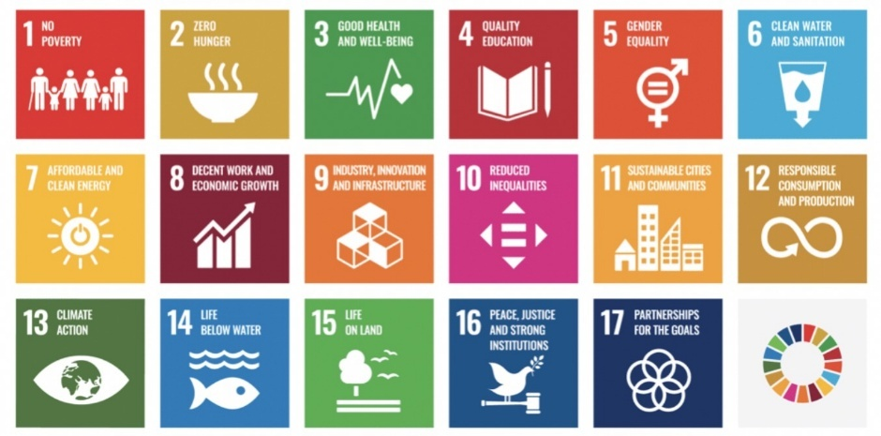
‘Leave no one behind’ is the central promise of the SDGs. It is a commitment by all UN Member States to eradicate poverty, end discrimination and exclusion, and reduce the inequalities that undermine the potential of individuals and of humanity as a whole.
The SDGs recognise that ending poverty must be accompanied by strategies to build economic growth and promote access to health, education, social protection and job opportunities, while taking action on climate change and environmental protection. The SDGs are unique in calling for action by all countries - rich, poor and middle-income – to promote prosperity while protecting the planet.

Tracking progress for change
Each SDG goal includes a set of sub-targets and indicators. Taken together, this is known as the global indicator framework and is used to assess progress and ensure accountability. The global indicator framework for the SDGs includes 230 indicators, which are used to monitor progress against 169 targets.
Mutually reinforcing human rights
The SDGs and the 2030 Agenda for Sustainable Development are based on the principles of participation, inclusion, transparency and accountability, which are also key human rights principles.
The SDGs are also linked to human rights standards in very practical ways. More than 90% of the 169 SDG targets are embedded in human rights treaties. It means that without progress to implement these human rights treaties, 90% of SDG targets cannot be realised.
This linkage creates opportunities to develop integrated approaches for implementing and monitoring progress on the SDGs and human rights, across a range of shared social, economic and environmental priorities.
In relation to the right to a healthy environment, specifically, there are close links with:
- Goal 6: Clean water and sanitation
- Goal 7: Affordable and clean energy
- Goal 11: Sustainable cities and communities
- Goal 12: Responsible consumption and production
- Goal 13: Climate action
- Goal 14: Life below water
- Goal 15: Life on land
Implementing the SDGs is essential to achieve environmental outcomes that best support the survival of humanity and our planet’s rich biodiversity.
“We are determined to protect the planet from degradation, including through sustainable consumption and production, sustainably managing its natural resources and taking urgent action on climate change, so that it can support the needs of the present and future generations.”
Preamble to the 2030 Agenda for Sustainable Development

NHRIs: Crucial partners for monitoring and implementation
Given their unique mandate and role, national human rights institutions (NHRIs) can play a vital role in the implementation and follow-up of the SDGs and the 2030 Agenda.
Their independent monitoring mandate allows NHRIs to act as both watchdog and advisor to promote progress on realising the human rights outcomes embedded in the SDGs.
Indeed, the important role of NHRIs, their establishment and operation in compliance with the Paris Principles is specifically noted in the SDGs.

Goal 16: Promote peaceful and inclusive societies for sustainable development, provide access to justice for all and build effective, accountable and inclusive institutions at all levels.
- Target 16.a: Strengthen relevant national institutions, including through international cooperation, for building capacity at all levels, in particular in developing countries, to prevent violence and combat terrorism and crime.
- Indicator 16.a.1: Existence of independent national human rights institutions in compliance with the Paris Principles.
In relation to the right to a healthy environment, NHRIs can support the SDGs goals and targets by:
- Monitoring progress at the local, national, regional and international levels, including by building on existing human rights reporting and monitoring mechanisms.
- Assisting in the development of national indicators and sound data collection systems, including by providing advice and expertise on a human rights-based approach to data collection.
- Promoting transparent and inclusive processes for participation and consultation in the development of national strategies, especially for marginalised communities, and by collaborating with civil society and other actors.
- Supporting capacity-building and sharing of experiences on a human rights-based approach to the SDGs.
The Mérida Declaration was adopted by NHRIs at the 12th International Conference of the Global Alliance of National Human Rights Institutions in 2015.
The Declaration reaffirms the mutually reinforcing nature of SDGs and human rights and emphasises that “NHRIs in all regions are already addressing issues of crucial importance to the [2030] Agenda in their regular work”.
