**STS USER INTEGRATIONS – EMAIL PROGRAMS**

STS Cloud has two features allowing you to easily send emails into your database, capturing email notes above you signature line and creating a completed activity in STS Cloud. This eliminates the copy and pasting manually of email notes into STS Cloud activites. This feature is used as you determine based on the email notes your want to capture at any time.

Also, any activity created with a time (IE-Site Tour, attending a networking event, etc) will be added to your User Dashboard in STS Cloud and a copy will update into your Outlook program once you set the iCalendar up within your email progrm.

Users are given two items that will work with any email program. The first is a custom Email Dropbox address, the second is a custom user URL to build a second calendar in your email program.

If a multi property user, you will have a unique email address for each database. Log into each database to get your email addres to use in BCC, as they are database specific links.

**EMAIL DROPBOX:**

To use your email dropbox address:

1. Click the Utility Wheel next to your name
2. Click Settings for your Username
3. Verify the email address listed in your Personal Information section matches the email address used in your Outlook, Gmail, etc. (this is a security setting and both need to match)
4. Scroll down the page to Integrations
5. You will see your custom email address
6. Highlight the addres and click the CTRL+C keys to copy this address

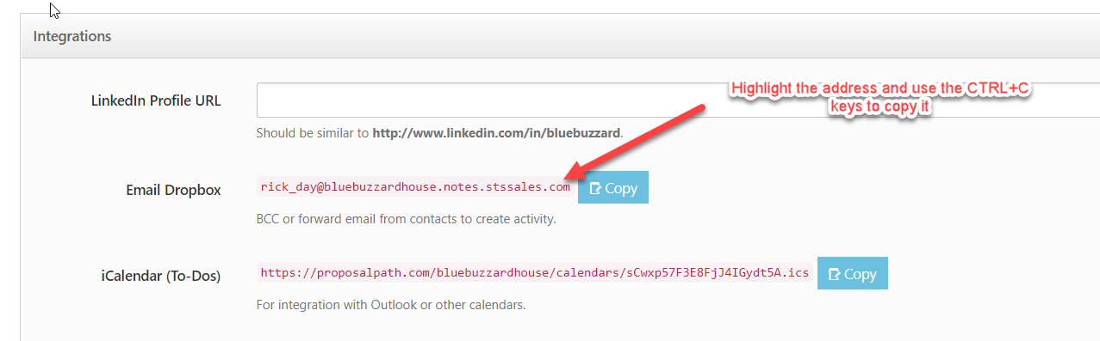

Then, open your email program and click New for a new email

Enter the client email into the To field

Use CTRL+V to paste your STS Email address in the BCC field (then clients do not see you doing this)

NOTE: Salespersons can determine when they want to use this to capture their email notes as needed

Once you have copied the email dropbox into the BCC field initially, you can quickly type the first letters of your address in the BCC field to pick and add to future emails as you need to use it.

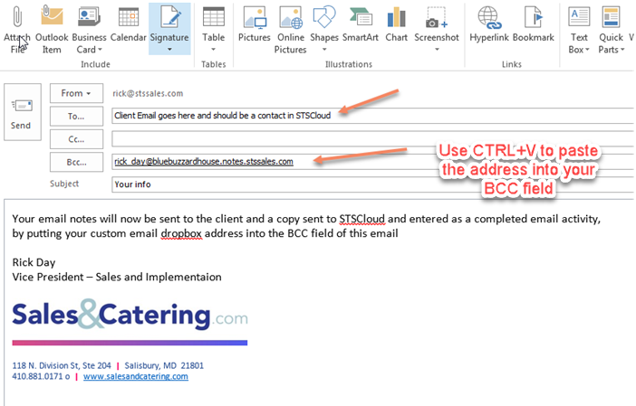

Type your email as usual. Once you click send, the client received their email in their inbox, and copy of your email is sent into your STS Cloud database. The system will locate the client email and create a completed email activity, saving you time from having to copy and paste notes manually.

Once processed in the system, you will see a completed Email activity in the account history

EX:

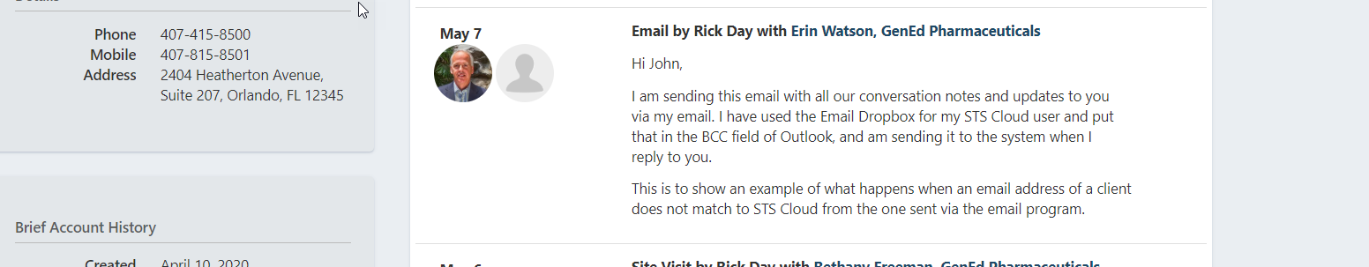

**PERIODIC EMAIL DROPBOX CHECK IN STS CLOUD:**

We have a tool in our Tools icon in the top menu bar of STS to allow you to periodically check STS Cloud to assure emails were auto connected to your contact/account. Sometimes a user may have a client email in their Outlook, but the contact in STS Cloud may be missing an email address, or it was mistyped. Note the following recommended to do a couple times weekly:

1. Click the Toools icon in the top menu bar
2. Click Email Dropbox
3. Once the screen opens, you should ideally see no emails listed. This will indicate all emails sent into STS have been matched to your contacts.
4. If you see an email listed, as in the below screen shot, that means STS could not find a client email address.

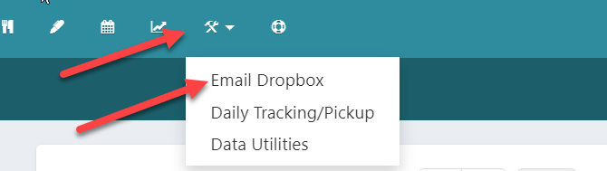

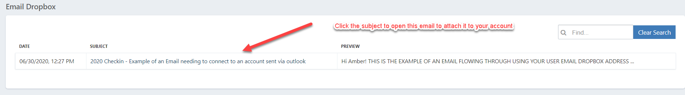

1. Click the subject line of the email listed
2. On the next screen Click Create New Activity from Email button

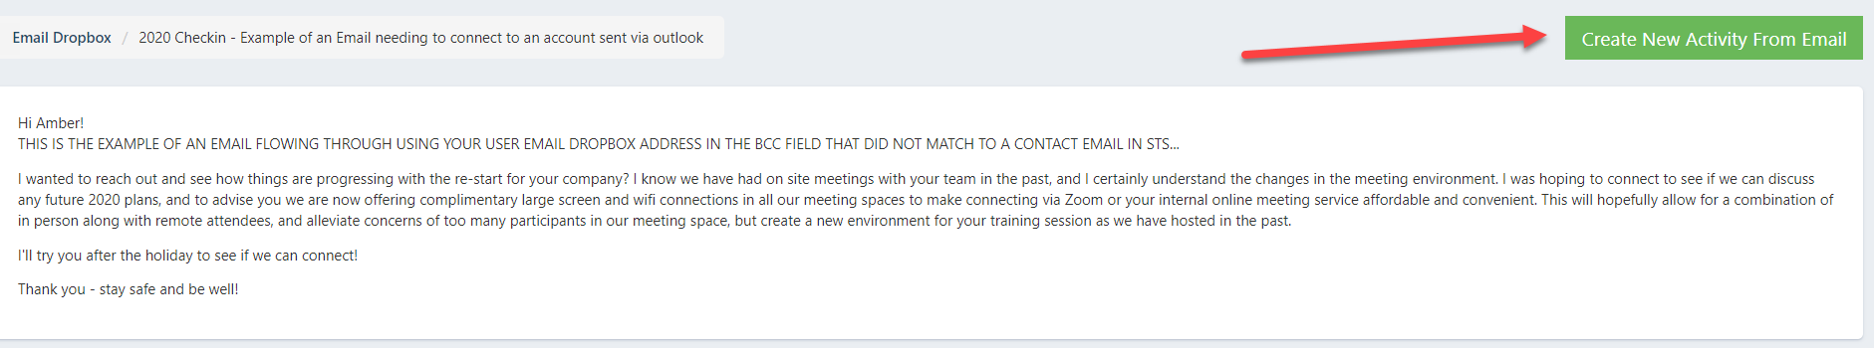

1. Lookup the account to move the email to, and select it in the Account Name

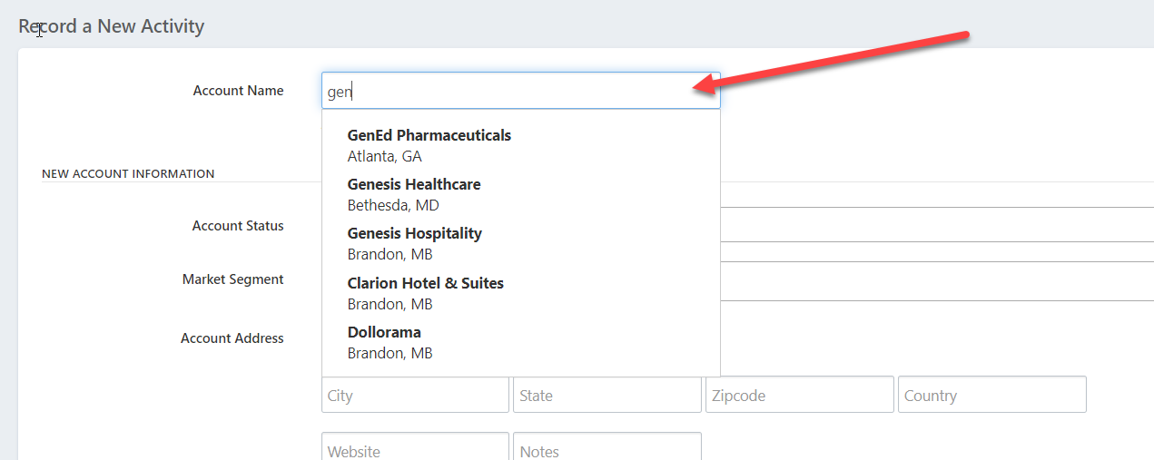

1. Scroll to the bottom and click save
2. That moves the Email into the correct account

**SETUP YOUR STS CLOUD iCAL (SECOND CALENDAR) IN YOUR EMAIL PROGRAM**

Setting up your iCal using your custom URL address for your Username is a one time setup to build the calendar into your Email Program. Once built, any time you create an activity in STS Cloud with a time for an appointment or other time sensitized activites, your appointment will show on your User Dashboard in STS Cloud and send a copy automatically to our Outlook or email calendar, so you do not have to manually add it yourself.

To setup the calendar:

1. Click the Utility Wheel in the top right next to your name in STS cloud
2. Click Settings for your username
3. Scroll down to Integrations
4. Highight and copy (using CTRL+C on your keyboard the full URL address in the iCal

**Outlook:**

1. Open Outlook or other program
2. Click File
3. Click Account Settings
4. Click the Internet Calendars Tab
5. Click New
6. Use the CTRL+V keys to paste the URL into the box as noted
7. Click Add
8. Once entered you can highlight the calendar and click Rename, and call it STS for easy reference
9. This will setup the second calendar to accept your scheduled appointments in Cloud.

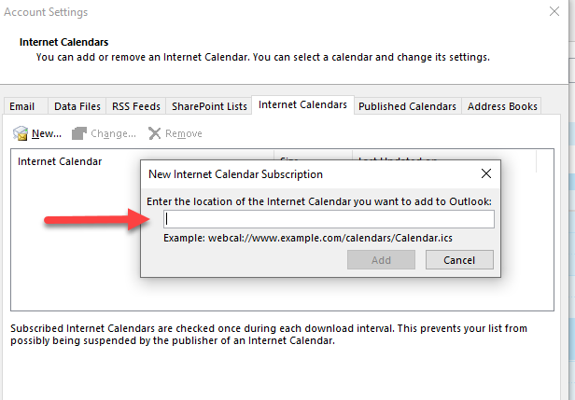

**Google Other Calendar**

You can only create new calendars from a browser, and not from the Google Calendar app. Once the calendar is created, you can find it on your browser and in the app.

1. On your computer, open [Google Calendar](https://calendar.google.com/).
2. At the left, next to "Other calendars," click Add other calendars Add and then Create new calendar.
3. Click from URL
4. Paste the iCal link from your user settings in STS Cloud
5. Click Add Calendar
6. Click the back arrow on the top left
7. Under Other Calendars, click the new Other Calendar with the https:// link
8. Click the three dots next to the new calendar and click Settings
9. Rename the Calendar to STS or whatever you want
10. Click the refresh button to see the name update
11. Once created in Google, any time you enter an activity in STS Cloud with a time it will update this new calendar in Google and add your event automatically