

DRS

Customer Release Notes
Version 6.1.2

Disclaimer
Copyright © Advanced Computer Software Group Ltd 2023.
This document contains confidential and/or proprietary information. The content must not be disclosed to third parties without the prior written approval of Advanced Computer Software Group Limited or one of its subsidiaries as appropriate (each referred to as “Advanced”). External recipients may only use the information contained in this document for the purposes of evaluation of the information and entering into discussions with Advanced and for no other purpose.
Whilst Advanced endeavours to ensure that the information in this document is correct and has been prepared in good faith, the information is subject to change and no representation or warranty is given as to the accuracy or completeness of the information. Advanced does not accept any responsibility or liability for errors or omissions or any liability arising out of its use by external recipients or other third parties.
No information set out or referred to in this document shall form the basis of any contract with an external recipient. Any external recipient requiring the provision of software and/or services shall be required to enter into an agreement with Advanced detailing the terms applicable to the supply of such software and/or services and acknowledging that it has not relied on or been induced to enter into such an agreement by any representation or warranty, save as expressly set out in such agreement.
The software (if any) described in this document is supplied under licence and may be used or copied only in accordance with the terms of such a licence. Issue of this document does not entitle an external recipient to access or use the software described or to be granted such a licence.
The development of Advanced software is continuous and the published information may not reflect the current status. Any particular release of the software may not contain all of the facilities described in this document and/or may contain facilities not described in this document.
Advanced Computer Software Group Limited is a company registered in England and Wales with registration number 05965280 whose registered office is at The Mailbox, Level 3, 101 Wharfside Street, Birmingham, B1 1RF

Table of Contents
Customer Release Notes 1
Table of Contents 3
DRS Version 6.1.2 1
What's new 2
A closer look 5
New Features 5
DRS 6886 – Change the way we can select sub objects 5
DRS 6867 - option to the PP config view to force to synchronize project packages period to project period. 6
DRS 5642 – Make Apache patchable in DRS. 7
DRS 6737 - Add a parameter in the setup to be able to redirect DRS to an url handled by a load balance 8
DRS 6486 - Amend WebService OrderCreate for jobs past Target Date 9
Fixes 10
DRS 6567 – Job not respecting both mandatory skill values when using Multi Template mapping. 10
DRS 6579 - jobs coming over with no address, no priority or description. 11
DRS 6654 - not able to use name from user on view filter 11
DRS 6662 - Users Cannot See Shared Shortcuts. 12
DRS 6782/6914 - Tenant Code Rules not working correctly. 12
DRS 6814 - Not displaying all operatives on planning board 13
DRS 6850 - Not able to load a Project after assigning it a Team 13
DRS 6887 - Unable to view Personal Views in DRS Upgrade v6 13
DRS 6915 - Visit templates listed that don't meet Tenant Warning Code rules. 14
DRS 6927 - Unable to use Meeting creation as there is no contract in drop down list. 15
DRS 6992 - Appointment Reminder Text Messages 16
DRS 6994 - Copying a quota calendar does not retain the quota details. 16
DRS 6996 - Current / Future Diary unable to be displayed - archived diaries showing ok 16
DRS 7004 – Update 7zip version due to security vulnerability CVE-2022-29072 17
DRS 7006 - Unable to use date filtering in Advanced Filter 17
DRS 7009 - Appointment template field appears twice in SOR Template screen 17
DRS 7027 - Unable to add daily unavailability for operative(s) 18
Release list of Components 19
Internal Component Versions 19
External Component Versions 20
Contact us 21

DRS Version 6.1.2
Development of DRS Version 6.1.2 is now complete and was released in April 2023.
DRS 6.1.2 is a patch release to further follow up on the release of 6.1.0. This release addresses a number of issues discovered since the release of 6.1.1.

What's new
This section describes the new or improved features we have introduced in this release and key fixes and improvements.
DRS 6.1.2
new | DRS - 6886 | Change the way we can select sub objects
new | DRS – 6867 | option to the PP config view to force to synchronize project packages period to project period.
new | DRS – 5652 | Make Apache patchable in DRS
New | DRS – 6737 | Add a parameter in the setup to be able to redirect DRS to an url handled by a load balancer
New | DRS - 6486 | Amend WebService OrderCreate for jobs past Target Date
FIXED | DRS – 6661 | Job not respecting both mandatory skill values when using Multi Template mapping
FIXED | DRS – 6579 | jobs coming over with no address, no priority or description
FIXED | DRS – 6654 | not able to use name from user on view filter
FIXED | DRS – 6662 | Users Cannot See Shared Shortcuts.
FIXED | DRS – 6782 / 6914 | Tenant Code Rules not working correctly
FIXED | DRS – 6814 | Not displaying all operatives on planning board
FIXED | DRS – 6850 | Not able to load a Project after assigning it a Team
FIXED | DRS – 6887 | Unable to view Personal Views in DRS Upgrade v6
FIXED | DRS – 6915 | Visit templates listed that don't meet Tenant Warning Code rules
FIXED | DRS – 6927 | Unable to use Meeting creation as there is no contract in drop down list.
FIXED | DRS – 6992 | Appointment Reminder Text Messages
FIXED | DRS – 6994 | Copying a quota calendar does not retain the quota details
FIXED | DRS – 6996 | Current / Future Diary unable to be displayed - archived diaries showing ok
FIXED | DRS – 7006 | Unable to use date filtering in Advanced Filter
FIXED | DRS – 7009 | Appointment template field appears twice in SOR Template screen
Fixed | DRS – 7027 | Unable to add daily unavailability for operative(s)

A closer look
This section provides extended information on key features and fixes

New Features

DRS 6886 – Change the way we can select sub objects
When selecting sub-objects from a dropdown users would run into an issue when there are a large number of items for selection.
when there are less than 15 items for selection a hover popup will be displayed showing the selectable items. When greater than 15 items a ‘Select xxx’ link will be shown which will take users to a popup grid where they can select from any of the available items.

DRS 6867 - option to the PP config view to force to synchronize project packages period to project period.
When modifying the project period the project packages period is not altered to match. We have found that for most customers they view these two values as the same thing.
A new parameter has been added that will keep both periods in sync. By default this is set to true, previous functionality can be restored by setting this value to false.
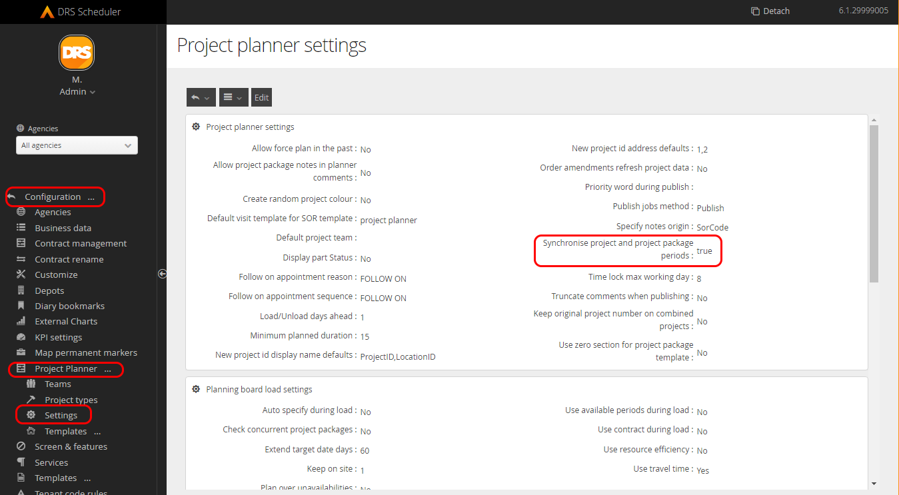

DRS 5642 – Make Apache patchable in DRS.
Previously when a new release of Apache was made available it would not be able to be applied to existing versions of DRS and would only be available to the next patch release.
This change makes it possible for the version of Apache to be updated independently of a DRS upgrade.
Command details
The command works by running “call util PATCH_PACKAGE %package% %version%” where :
%package% is the name of the package to upgrade. (“apache” is the only possible value at the moment)
%version% is the version number to upgrade to.
Requirements
Before running the command, you need to place the package update file in the REPOSITORY folder.
The example below updates apache from 2.4.56.0 to 2.4.57. placing the file “apache.2.4.57.7z” in the REPOSITORY folder of the setup.
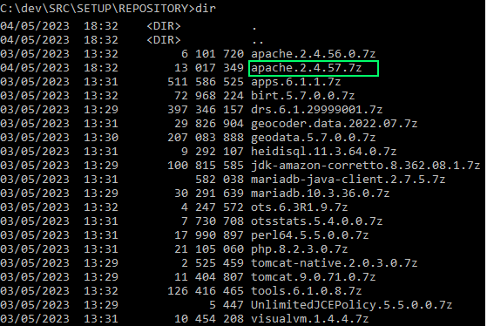
Package 7z file content
The Apache 7z file must contain at its root level all the files (they must not be in a subdirectory).
The Visual C++ redistributable install file must be placed in a directory named “VCRedist”
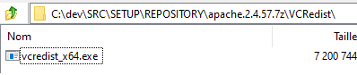
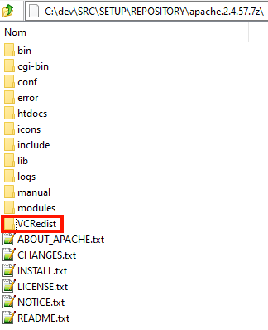

DRS 6737 - Add a parameter in the setup to be able to redirect DRS to an url handled by a load balance
an optional parameter has been added into DRS to allow redirections to be done on a public URL (behind a load balancer).
A new parameter has been added to the setup : PROXY_EXTERNAL_URL. If this contains an URL (https://xxxx), DRS is supposed to be publicly accessible from that URL behind load balancer, and redirect to the internal DRS URL (OTRMS_HOST).

DRS 6486 - Amend WebService OrderCreate for jobs past Target Date
In previous versions it was not possible to create an order date where the Target date was in the past. It was however possible to do this via flat file where the target date would be automatically updated to current time + 24hrs.
The webservice has had an additional parameters added which allows to turn on the functionality to have the same behaviour applied to orderCreate calls.
2 new parameters have been added to OTWSG with default values.
optitimeweb.ExtendTargetDateAndPWIfInPast=false
optitimeweb.ExtendTargetDateAndPWDaysToAdd=1
If ExtendTargetDateAndPWIfInPast = false then the OTWSG behaves as before (ie an error if targetdate < earliestBookingDate and no error if both are in the past but targetdate > earliestBookingDate).
If ExtendTargetDateAndPWIfInPast = true then
If the targetDate is before the current time it is updated to NOW + (ExtendTargetDateAndPWDaysToAdd) days.
If the EarliestBookingDate is still later than the new targetDate then it is set to NOW (This is to stop the order being rejected because they supplied an earliestBookingDate which is greater than the target date)

Fixes

DRS 6567 – Job not respecting both mandatory skill values when using Multi Template mapping.
When a job is created by SOR multi template mapping it is not respecting both skills if the job has two mandatory skill values. This was allowing the job to be scheduled to an operative that does not have both skills.
This has been corrected so that multiple mandatory skills are recognised, this can be used in the two following ways.
- All skills mandatory
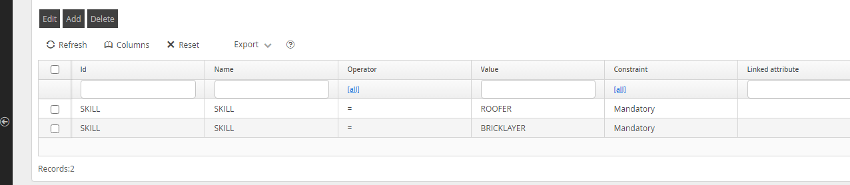
In this configuration, the selected operative must have all of the mandatory skills. This is displayed on the job as below:
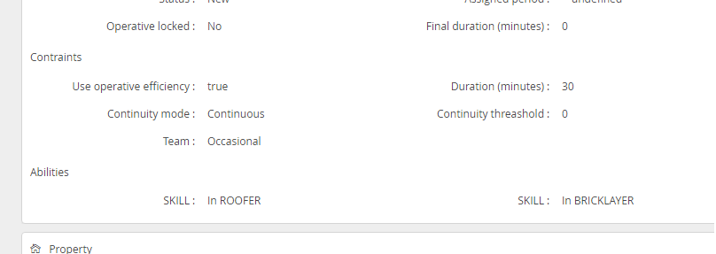
- 1 of skills is mandatory.
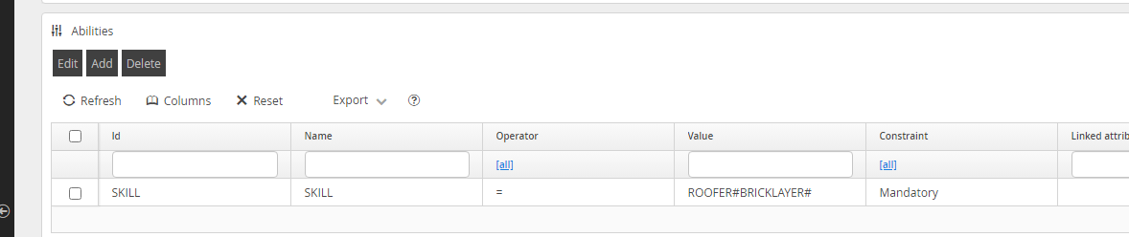
When using the # separator, this will cause the skills to be treated as 1 of the listed skills. And will be displayed on the job as below:
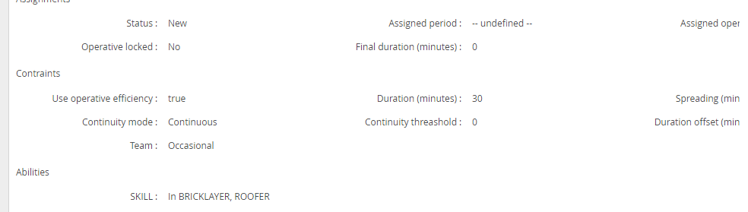

DRS 6579 - jobs coming over with no address, no priority or description.
In some circumstances Jobs coming to DRS from Job Manager would not correctly populate the sync database. This results in some confusion and requires jobs to be edited and saved to correct the missing data.
The addOrder request process has been updated and should now always populate data into the sync tables. Additional two redundant fields have been removed. (PP_WP_ID and PROJECT_PLANNER_JOB)

DRS 6654 - not able to use name from user on view filter
Using =VAR(user.name) on a filter was no longer allowing users to filter based on the username of the current user.

This has been fixed and should now return results as expected.

DRS 6662 - Users Cannot See Shared Shortcuts.
Users were on occasion finding that they were unable to see shared shortcuts.
This was found to be caused by profile names with an additional space before or after the username. A fix has been applied to remove any errant spaces before or after a profile name to correct this issue.
Shared views should now correctly be displayed at all times.

DRS 6782/6914 - Tenant Code Rules not working correctly.
User where finding that in some situations tenant code warning were not being displayed as expected.
This was found to be when the tenant code rules were checked and the new template id was returned, the model id field was updated on the job, but all other template fields were taken from the original template. This meant worker requests still related to the original template even though the model id was the new template id.
This has been fixed so that when the check for tenant code rules returns a new template id, it then selects the template and updates all the relevant fields on the job.

DRS 6814 - Not displaying all operatives on planning board
When attempting to view the planning board for a number of project packages operatives would sometimes be excluded from the planning board.
This was happening because originally the object ids selected to show on the planning board had a date range. This date range is compared to the projectPackageScheduleItem.PlannedPeriod_start. Only object ids which fall inside this date range are selected to prevent huge amounts of ids being returned. However, this only makes sense if we’re only selecting workers or customers.
The date range check will now only be used if we are selecting workers or customers, not project or project packages.

DRS 6850 - Not able to load a Project after assigning it a Team
A situation could occur where DRS was unable to load a project after assigning a team to it resulting in a “Error while getting HTTP request answer.” Error.
This was found to be an error resulting in an endless loop eventually resulting in a timeout in the UI and the process continuing to run using CPU. This has now been fixed.

DRS 6887 - Unable to view Personal Views in DRS Upgrade v6
When logging in but not using the exact case of the user personal views would not be displayed.
This has been corrected and is no longer case sensitive.

DRS 6915 - Visit templates listed that don't meet Tenant Warning Code rules.
It was found that when raising a visit that you are warned that "Only valid templates associated to the tenant warning code XX can be scheduled". However, despite this all visit templates are shown all of the time when raising a visit.
A problem was found that even though the job view controller knows there is a tenant code rule and that the list of templates should be restricted, it wasn’t passing the customer id to the job template list so it will always display the full list.
This has been updated so that if the job template list needs to be restricted by a tenant code rule the customer id is passed to the job template list so that it can load the restricted list.

DRS 6927 - Unable to use Meeting creation as there is no contract in drop down list.
When attempting to add a contract for a meeting if there were too many possible options the dropdown would error and show nothing.
This has now been altered so that paging can be used in the dropdown if there are more than 100 records to show using the PgUp and PgDn keys. 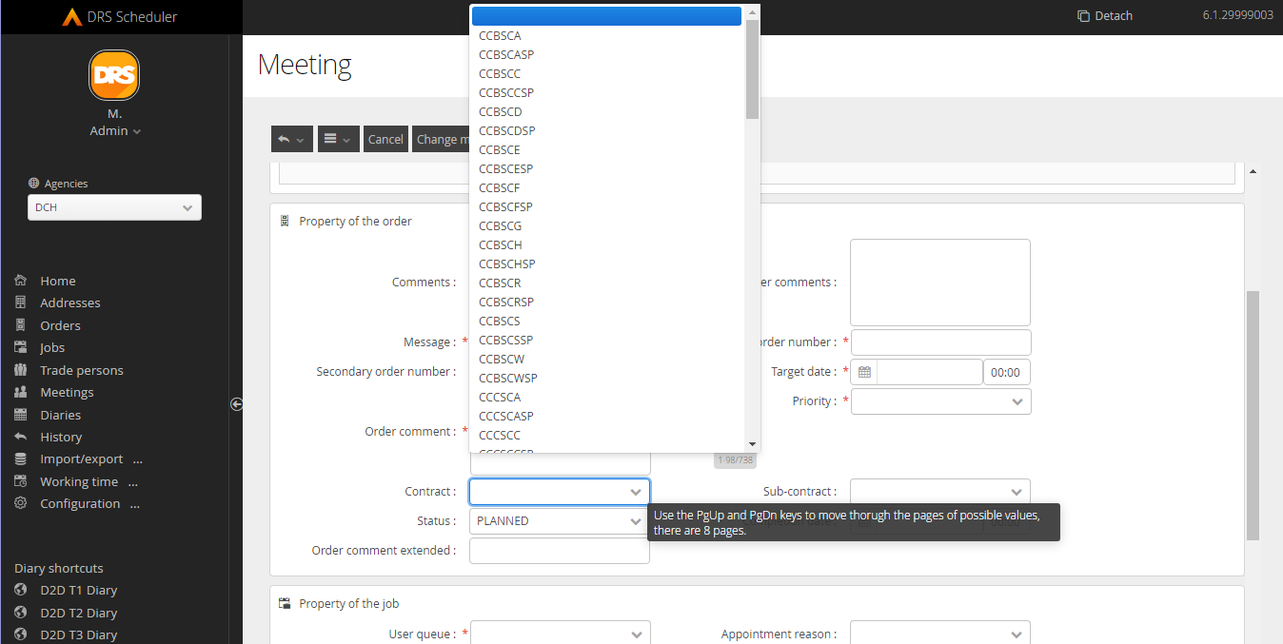
There is however a known issue with existing worker views attempting to use a column (Worker_WORKER_CLASSIFICATION) which no longer exists which can cause errors. This can be corrected by removing these rows from sui_view_element. However, a more permanent fix will be added to the upgrade process at a later date.

DRS 6992 - Appointment Reminder Text Messages
Some customers were having issues where appointment reminder text messages were not being sent out as expected.
this was found to be a bug with the phone number validation around country code validation where the reminder process would not correctly process some entries based on the initial coding of the number (+447, 447, 07 etc)
This has now been corrected and should correctly handled valid phone numbers in all formats.

DRS 6994 - Copying a quota calendar does not retain the quota details.
When copying a calendar with quotas enabled the quota information is not visible to the user on the copy.
The issue here is rather than it not being copied is that for the copy the setting to display the quotas was disabled so it appeared they were not present. This has been corrected so that if there are quotas when copying the calendar should be set to display them automatically.

DRS 6996 - Current / Future Diary unable to be displayed - archived diaries showing ok
In some circumstances diaries would not correct be displayed and would show blank.
This was found to be an issue when the getDiaryScheduleEvents is trying to add a new strip do the DiaryWorkerDay.
This has been corrected and should now always display the expected diary.

DRS 7004 – Update 7zip version due to security vulnerability CVE-2022-29072
A vulnerability was found with 7zip which could result in privileges being gained to execute arbitrary code.
We have taken the suggested steps to prevent this exploit and upgraded the 7-ZipPortable to version 2.2.2.1.

DRS 7006 - Unable to use date filtering in Advanced Filter
Advanced filters were not correctly allowing users to create views that use certain filters like “>d” for date filtering. This would result in an invalid filter err or message.
This has been corrected and all filter options available in previous versions should now work correctly.

DRS 7009 - Appointment template field appears twice in SOR Template screen
The appointment template field was incorrectly appearing twice in the SOR template screen
This has been corrected and the field should now only be displayed once.

DRS 7027 - Unable to add daily unavailability for operative(s)
When attempting to add daily unavailabilities for multiple operatives the process would fail.
This has been updated so that add and remove unaviliabliites can be processed via the background services. This should now work correctly.

Release list of Components

Internal Component Versions
Function | Version
DRS Server (Kernel) | 6.3.1.9
Background Service | 6.1.2
Connector Services | 6.1.2
Inbound Connector | 6.1.2
Mobile Gateway | 6.1.2
Project Planner | 6.1.2
Utility Service | 6.1.2
DRS Web Services Gateway | 6.1.2
Archive/Housekeeping | 6.1.2
UK Geocoding Postcode Database | 07/2022

External Component Versions

Description | Version
Apache | 2.4.57.0 (Upgraded from 2.4.56.0)
Java | 8.372.07.1 (Upgraded from 8.362.08.1)
MariaDB | 10.6.12.0* (Upgraded from 10.3.36.0)
MariaDB JavaClient (JDBC) | 3.1.2
php | 8.2.3
Tomcat | 9.0.75.0 (Upgraded from 9.0.71.0)
Tomcat Native | 2.0.3.0
.Net | 4.7
SoapUI | 5.5.0
*: need to execute on the server mysql-connector-net-8.0.33.msi instead of the 6.8.3. The 6.8.3 is still needed for previous DRS versions as the 8.0.33 will not work for them.

Contact us
At Advanced we strive to build intuitive products, but we also know that from time to time you may need a little extra help. That's why we offer useful support resources that you can dip in and out of when you need it. However, if you need help and support beyond the information provided here, the following are also available:
- Visit the Support Portal
- Make a general enquiry on 03300 602 102
- Contact us via the Advanced website


More information
w oneadvanced.com
t 03300 602 102
The Mailbox, Level 3, 101 Wharfside Street, Birmingham, B1 1RF
Advanced Computer Software Group Limited is a company registered in England and Wales under company number 05965280, whose registered office is The Mailbox, Level 3, 101 Wharfside Street, Birmingham, B1 1RF. A full list of its trading subsidiaries is available at www.oneadvanced.com/legal-privacy.

