QR SERIES
HOW TO SETUP INTERNET REMOTE ACCESS VIA DMZ
- Go to Main Menu and go to Network. Enable DHCP and make a note on IP address
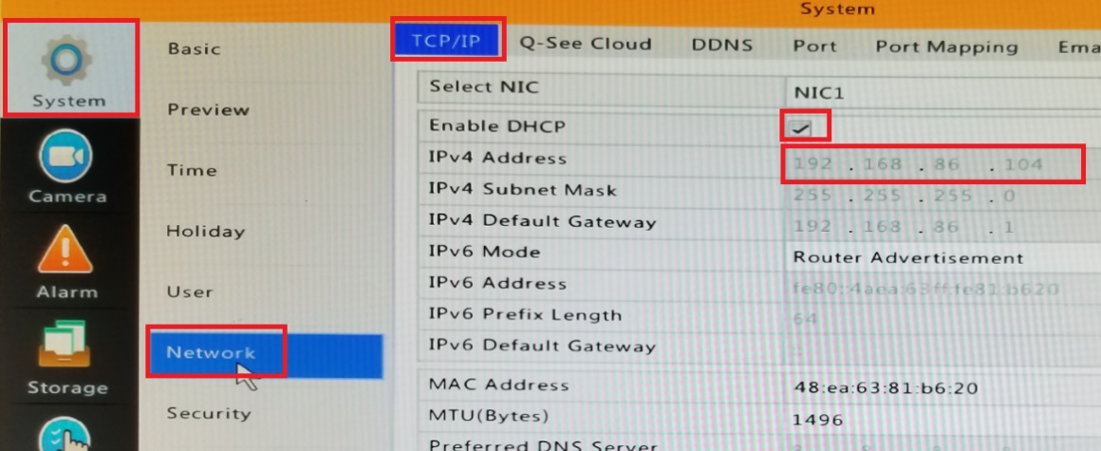

- Go to Port and make a note on port numbers
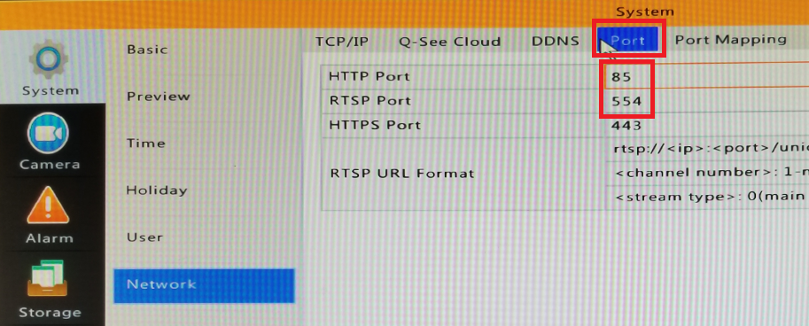

- Login to your Router from a computer.
- Find DMZ setting in the Router.
You can call your Router support or your ISP
Or you can Google: Where is DMZ setting in Netgear Router (example)
- Enable DMZ for the IP address of the DVR

This an example of enabling DMZ in Frontier Router.
- 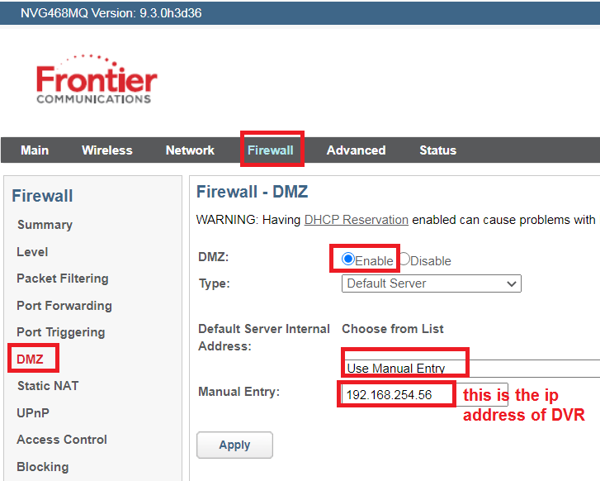

- From a computer on the same network as the DVR, go to www.canyouseeme.org
Your IP is your Internet IP address.
Port to check: 85 (http port as listed above) – Check port – Success
Then check one more port: 554 (rtsp port)

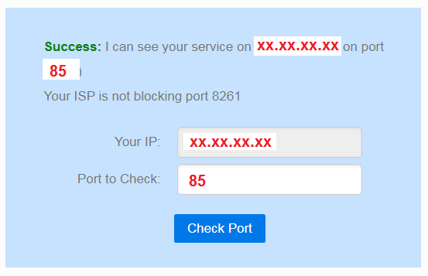
- If both ports are success, then you can use the IP address listed in canyouseeme to remote access your system from Phone or Computer.
- Example how to set the Presidio App on your phone:
