QC SERIES BLACK INTERFACE
HOW TO SETUP INTERNET REMOTE ACCESS VIA DMZ
- Go to Main Menu
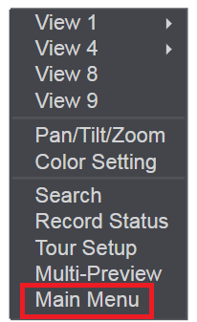
- Go to SETTING
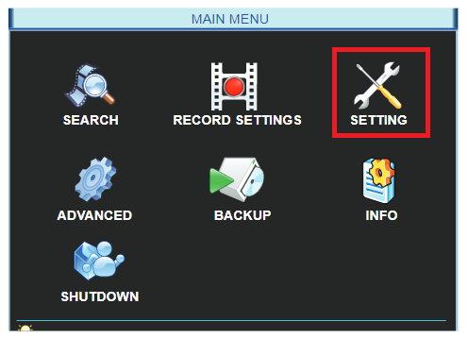

- Go to Network
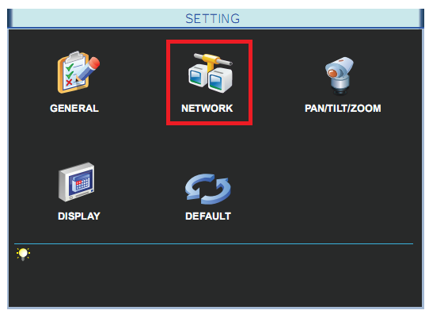

- Enable / Select DHCP – then click SAVE.
Make a note on the IP address
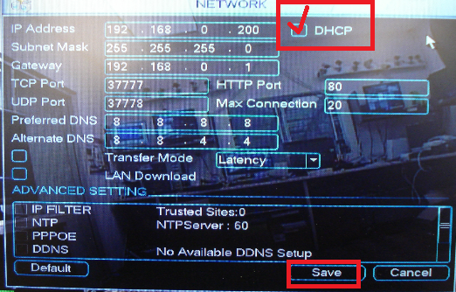

- Login to your Router from a computer via web browser.
- Find DMZ setting in the Router.
You can call your Router support or your ISP
Or you can Google: Where is DMZ setting in Netgear Router (example)
- Enable DMZ for the IP address of the DVR ( from step 4 above).

This an example of enabling DMZ in Frontier Router.
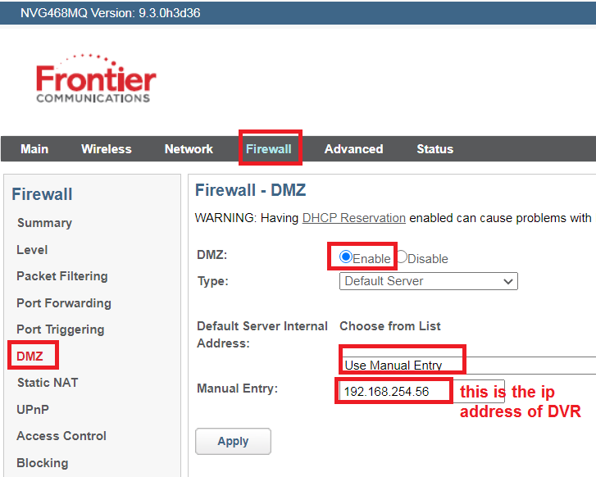

- From a computer on the same network as the DVR, go to www.canyouseeme.org
Your IP is your Internet IP address.
Port to check: 80 (HTTP port as listed above on step4) – Check port – Success
Then check one more port: 37777 (TCP port)

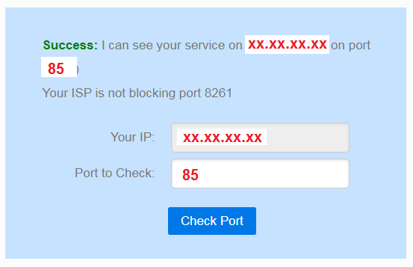
- If both ports are success, then you can use the IP address listed in canyouseeme to remote access your system from Phone or Computer.
- Example how to set the QCVIEW App on your phone:

