QT SERIES NEWER INTERFACE
HOW TO SETUP INTERNET REMOTE ACCESS VIA DMZ
- Go to Main Menu and go to NETWORK
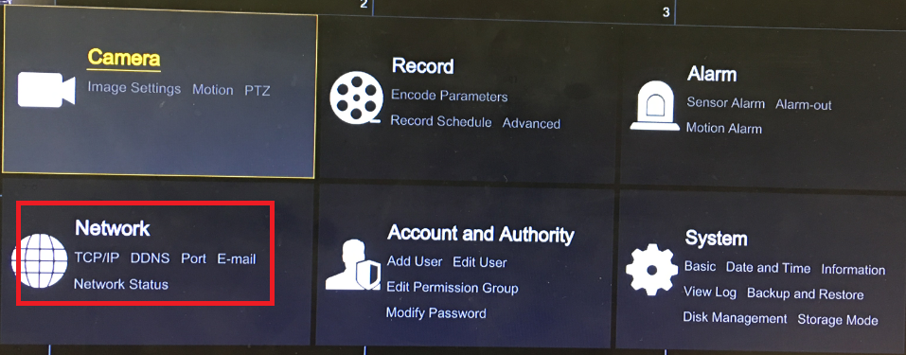
- Enable Obtain IP automatically – then click Apply. Make note on IP address
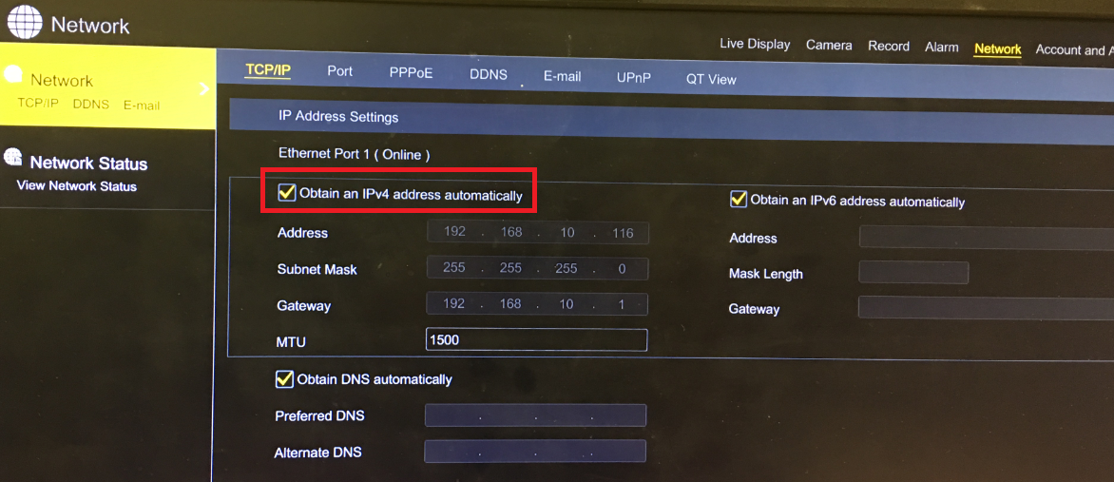
- Login to your Router from a computer.
- Find DMZ setting in the Router.
You can call your Router support or your ISP
Or you can Google: Where is DMZ setting in Netgear Router (example)
- Enable DMZ for the IP address of the DVR ( from step 2 above).
This an example of enabling DMZ in Frontier Router 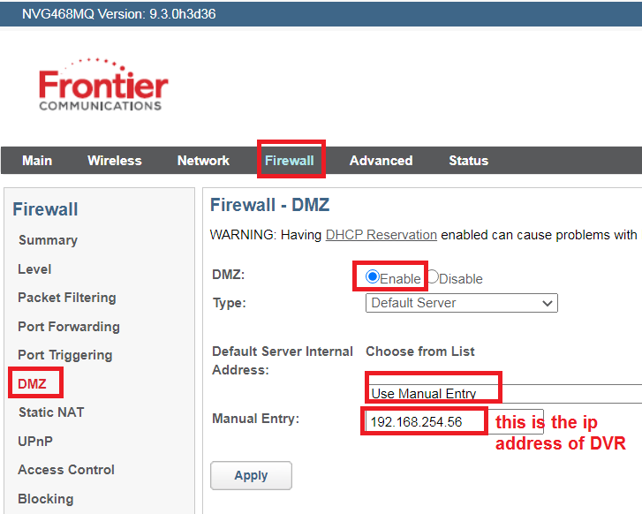
- From a computer on the same network as the DVR, go to www.canyouseeme.org
Your IP is your Internet IP address.
Port to check: 85 (HTTP port as listed above) – Check port – Success
Then check one more port: 6036 (Server port)

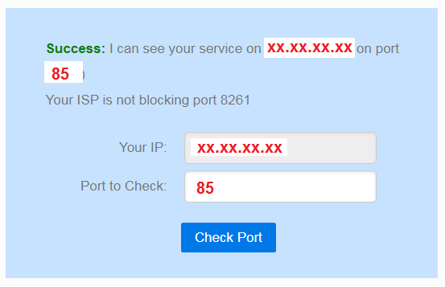
- If both ports are success, then you can use the IP address listed in canyouseeme to remote access your system from Phone or Computer.
- Example how to set the QTVIEW App on your phone:
