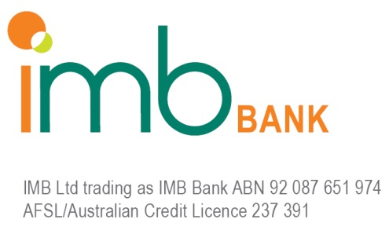

IMB COMMERCIAL – ACCREDITATION REQUEST

Aggregator Group: | Name of Aggregator BDM:  Email Address:  Phone Number:

Company name and A.C.N.

Trading Name of Referrer |  | A.B.N:

Broker / Principal’s Details (Contact #1) | Name:  Date of Birth:
Broker / Principal’s Details (Contact #2) | Name:  Date of Birth:

Company Address
(Include postal address if this is different from the street address)

Telephone Number
Facsimile Number
Mobile Number
Email Address
Type of Business

Are you or your company ASIC registered/licensed (Y/N)? |  | If yes, what is your/your company’s  registration/licence number?
Is your company a credit representative of your aggregator (Y/N)? |  | If yes, what is your company’s credit representative number?
Are you personally a credit representative of your company or aggregator (Y/N)? |  | If yes, what is your credit representative number?

Broker Experience:

IMB BDM Comments: (to include date of accreditation session)

IMB Business Development Manager | Paul Clarke
State | Victoria
Date
Signature

Broker Admin Use ONLY

Completed Accreditation request form held? | ❒ | Date:
Confirmation from IMB BDM applicant has attended accreditation session? | ❒ | Date:
BDM confirms Broker on Aggregator List. | ❒ | Date:
Date Code issued to Broker: | ❒ | Code:

