
MLB Audits and Addressing Corrective Action Guidance

This guide will assist you with addressing your Corrective Actions post a compliance audit being completed.
Once an audit has been completed, you will receive Two emails which will show as coming from info@audits.spfgroup.com.au
Email 1:
Will be titled ‘File Audit Report’ and contain a comprehensive report along with the due date for completion of corrective actions.
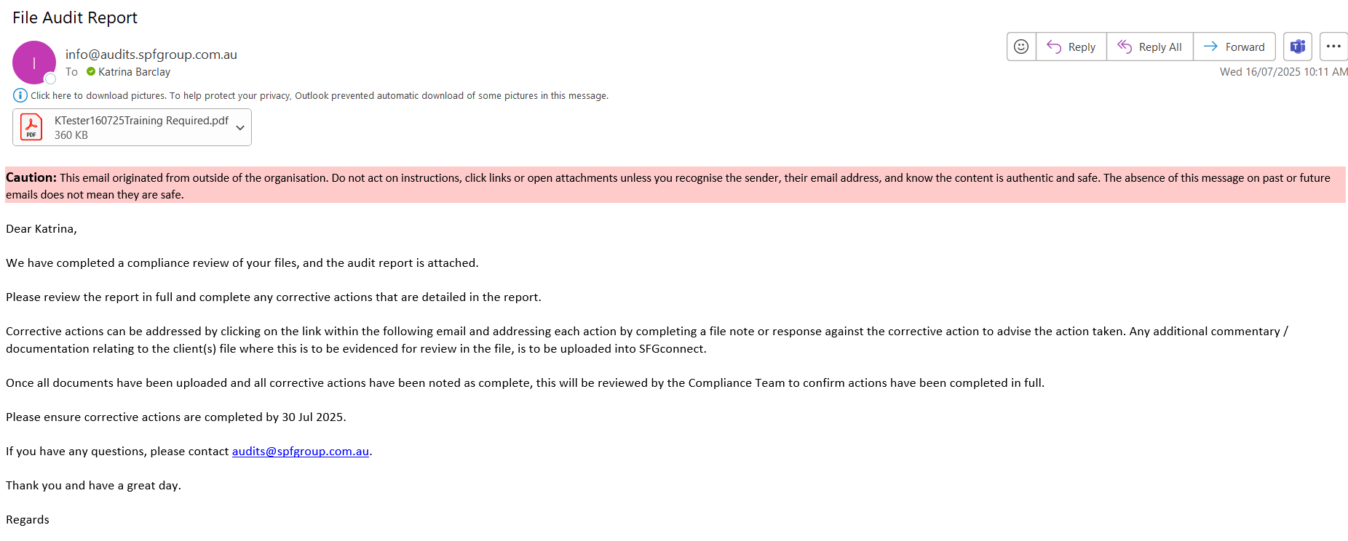

The report details the name of the files which have been audited, the outcome of each file under the ‘File Review Outcomes’ and then the overall ‘Rating’ outcome of the audit.
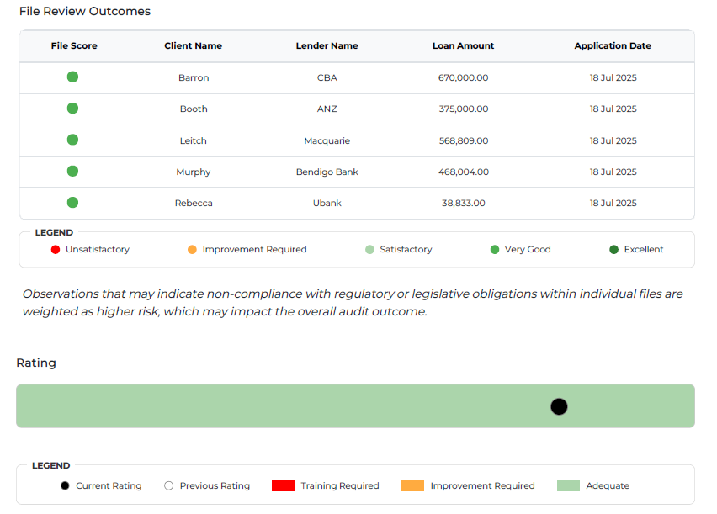
1\\\\\
1\\\\\
1\\\\\
1\\\\\
1\\\\\

The ‘Observations’ section of the report will detail the issues identified, list the name of each file the issue was identified on, specific commentary for each file name and provide an explanation of ‘Why this Matters’.
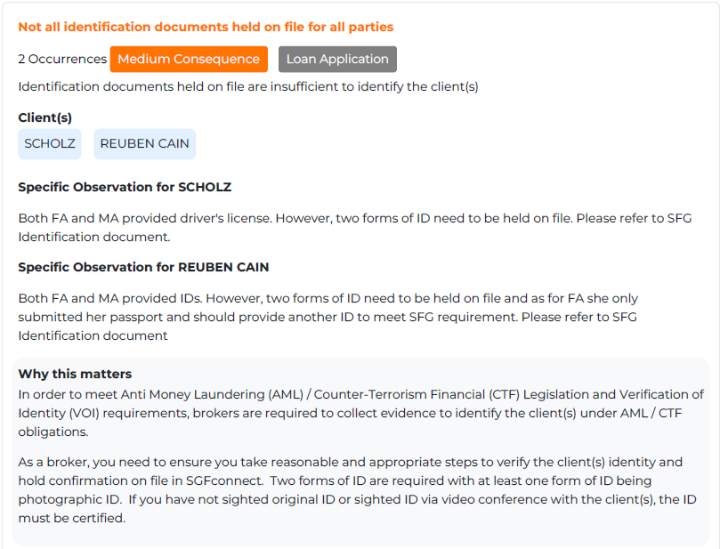

The report also has an ‘Observation Summary Table’ which shows the outcome for each file under each test question. Green – Satisfactory, Amber – Improvement Required, Red – Unsatisfactory.
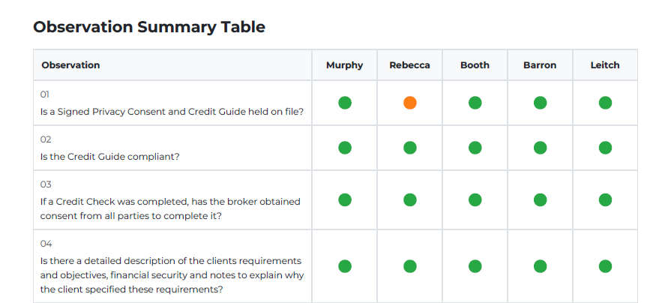
1\\\\\

Email 2:
Will be titled ‘Action Required: Audit Corrective Actions’.
This email provides access to a portal to complete your correctives actions and request closure. Click the link in the email to access the portal.
Note: You will need to review the Audit Report in conjunction with Corrective Action Portal.
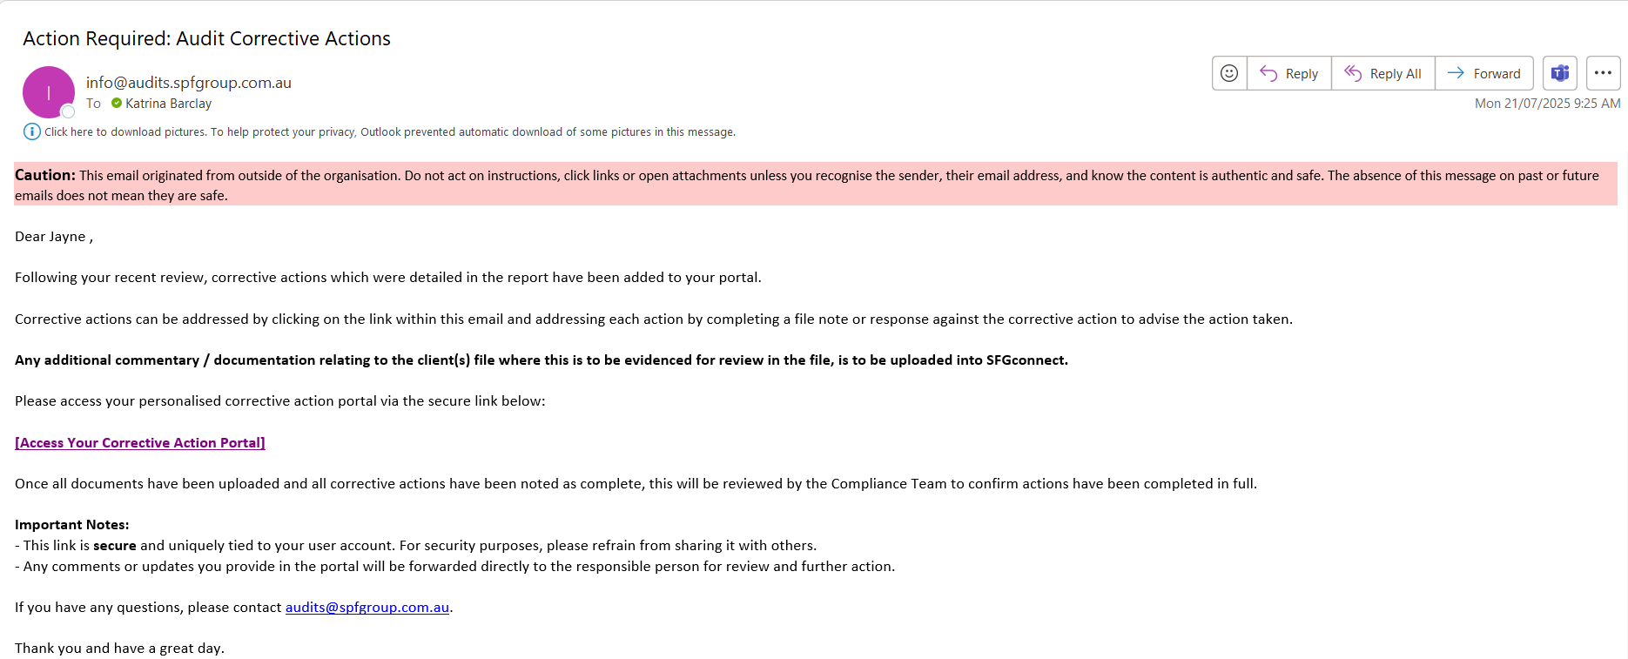

The list of corrective actions will then show.
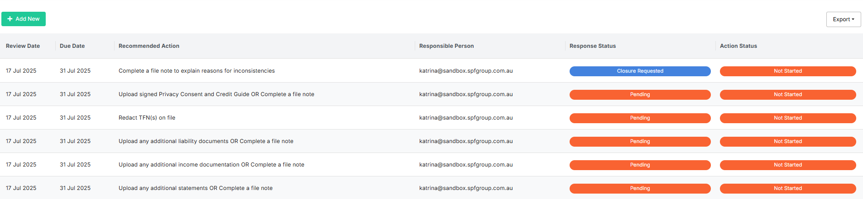

Click on each action to review which files the action relates to as it may relate to more than 1 of the files audited. Once the actions have been completed for all relevant files, select ‘Request to Close’.
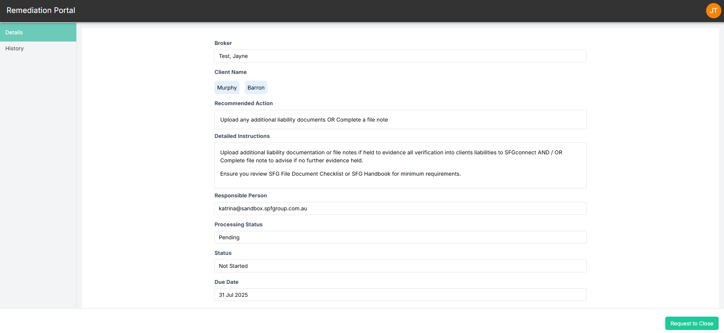

Complete the details of what has been actioned for each file and ‘Submit Request’.
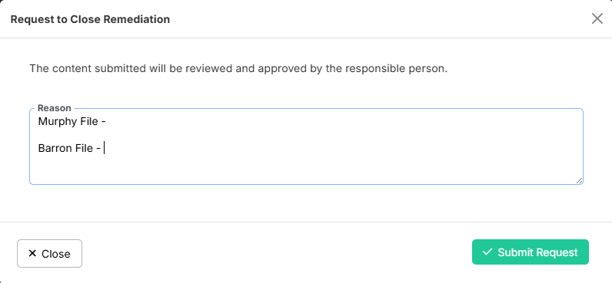

After hitting ‘Submit Request’, a green box will show in the top right of the screen to show the submission has been successful.
To go to the next corrective action, select ‘Back to List’ in the top left hand side of the screen and this will take you back to the list of corrective actions.
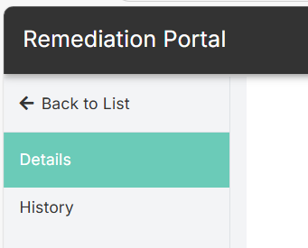
Once all actions have been completed and all show ‘Closure Requested’, an email is sent to the MLB Compliance Team to advise ready for final review.
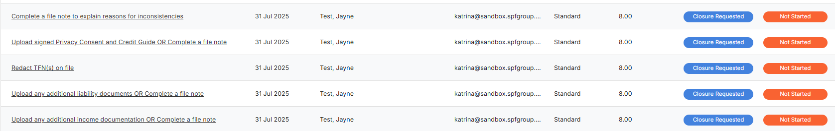
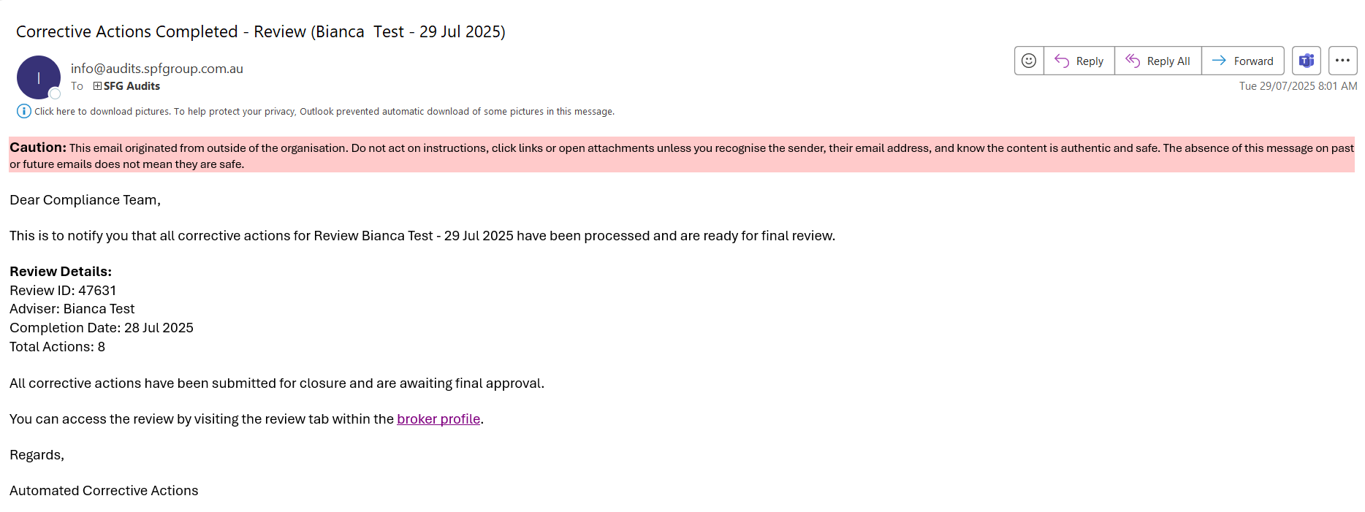

The MLB Compliance Team will review and once all corrective actions have been closed out, an email titled ‘File Audit Corrective Closed <Broker Name>’ will be sent to advise all corrective actions have all been closed.
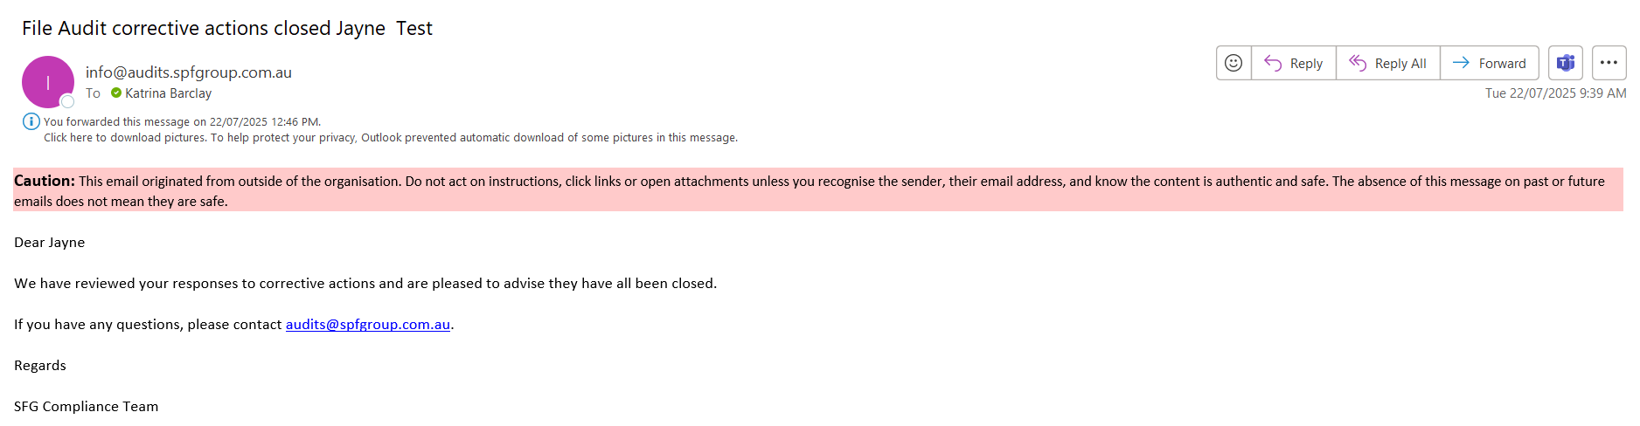
The MLB Compliance Team will contact you if there are any issues with any actions taken for the request for closure.

