Slack Support

Use Guide

Slack Support Tab
You can now raise tickets and request support from within Slack.

What is the support App?
The support app located in the apps section, enables you to create new tickets and chat with support, from within Slack.
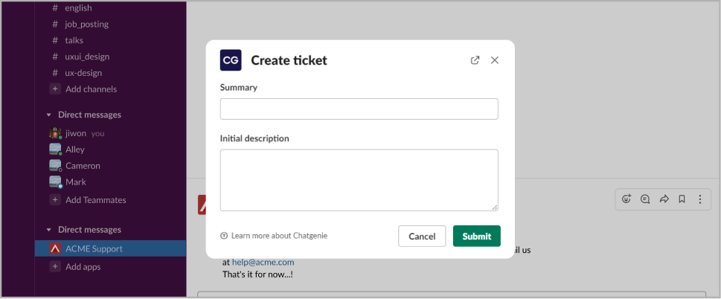
Where can I find the app?
The App should be located in the left navigation under Apps. If the App is not in the list, click “Add app” and search for it.
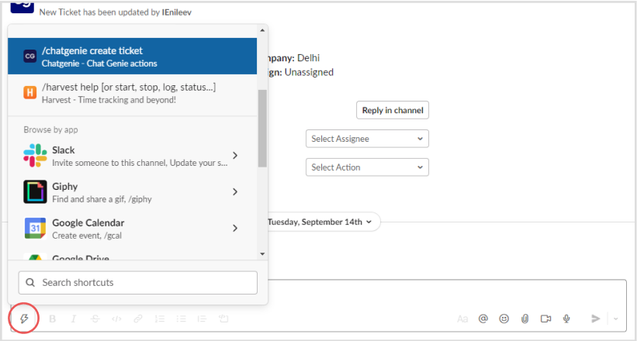

How can I raise new tickets?
You can use the shortcut “/shortcut” in the reply box or click the shortcuts icon and select it anywhere in Slack.

via the Ticket emoji reaction
You can also create a new ticket from the helpdesk channel by using the ticket emoji 🎫 as a reaction to create a ticket from that.
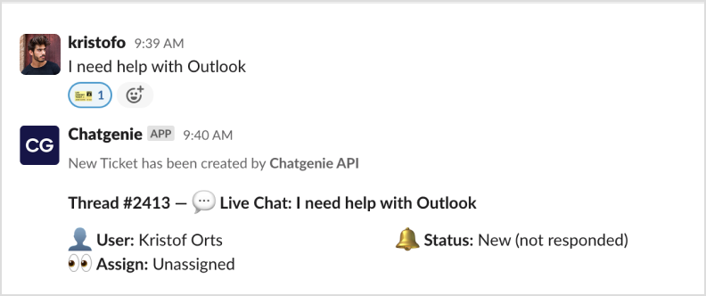

via the Home tab
The first tab in the app is the Home tab. Here you can find and overview of all your active and done tickets. Click New thread to open a new ticket.
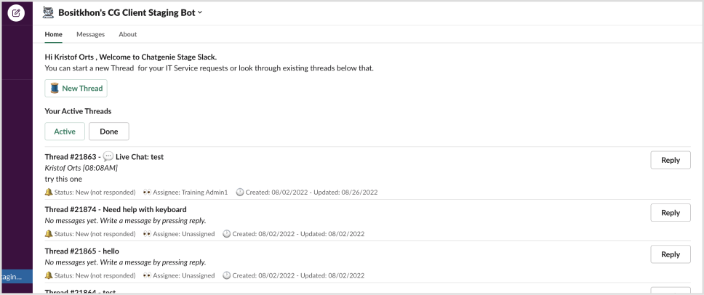

How do I reply to tickets?
You should see a card with the ticket information and a reply from the bot. Click on reply to open the thread and type your reply in the thread.
