Desktop Support (Mac)

Use Guide

Where do I find Thread Messenger?

You’ll find Thread Messenger in Status Menu tray of your Mac Desktop (pictured below):

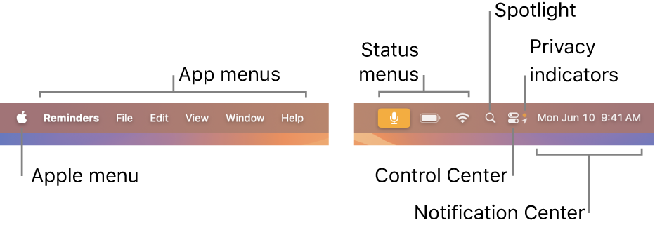

The default Messenger icon looks like this:



How do I log in to Messenger?

After clicking on Messenger for the first time, you will be presented with the Thread Messenger login prompt:

To log in, simply enter your corporate email address:

If your email is found by Thread, you will be prompted for a second form of authentication via email (as shown below):

When successfully logged in to Messenger, you will be presented with your company’s User Support screen.

How do I ask for Chat Support via Messenger?

From the User Support screen, simply click on the New Chat button (as shown below):

You will be prompted for a description of the issue you’d like help with (as pictured below):

And our Service Desk will be right with you!

**Open Threads**   
This section displays information about the service requests currently active with your service provider.

#6182: This number corresponds to the request in your service provider’s ticketing system.   
STATUS: This value shows the status of your request.   
10/14/2024: The date value in the top-right corner shows the age of the service request.