Please copy this section for each change. Change requests should be submitted to help.bigelow.org category: Website edit

URL: https://www.bigelow.org/about/people/mlomas.html

Section: Publications

Overview: Please add the following publications

Changes:

Garcia, C.A., Hagstrom, G.I., Larkin, A., Ustick, L., Levin, S.A., Lomas, M.W., Martiny, A.C. 2020. Linking biome shifts in microbial genome adaptation with ocean biogeochemistry. Proceedings of the Royal Society, B. 375: 20190254.

Lomas, M.W., Eisner, L.B., Jeanette Gann, Baer, S.B., Mordy, C.W., Stabeno, P.J. 2020. Time-series of direct primary production and phytoplankton biomass in the Southeastern Bering Sea: Responses to cold and warm stanzas. Marine Ecology Progress Series, accepted.

Please copy this section for each change. Change requests should be submitted to help.bigelow.org category: Website edit

URL: https://www.bigelow.org/about/people/mlomas.html

Section: Publications

Overview: Please add the following publications

Changes:

Phytoplankton Ecology and Biogeochemistry Laboratory
The Phytoplankton Ecology and Biogeochemistry Laboratory (PEBL) studies the role of phytoplankton physiology and biodiversity of phytoplankton assemblages in controlling ocean biogeochemical cycles and in particular the ocean's biological carbon pump. Some of our current projects are described below.

Bermuda Atlantic Time-series Study (BATS): The BATS program is one of the longest running biogeochemical time-series in the world. Sampling has continued monthly sampling since October of 1988. The program, based in the northwest corner of the Sargasso Sea, is designed to understand the time-variable nature of the dissolved (carbon dioxide) and particulate (biological carbon pump) carbon cycling in the ocean. Lomas was the managing PI of the BATS program from 2001- 2012, and continues to be involved as a co-PI. The PEBL group is responsible for measurements of phytoplankton diversity, specifically picoplankton identified by flow cytometry, and the cycling of phosphorus at BATS. More information on the BATS program can be found here: http://www.bios.edu/research/projects/bats/.

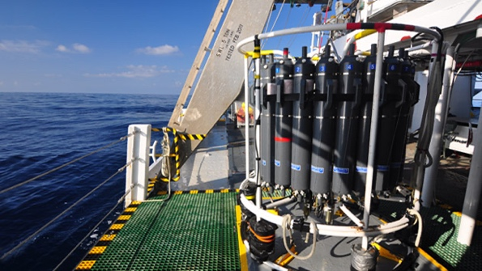
[IMAGE: BATS_program.png ALIGN: right]

Bering and Chukchi Sea primary production and foodwebs. The PEBL group has been studying the primary production and phytoplankton diversity in the eastern Bering Sea since 2008, first by participation in the Bering Sea Ecosystem Study program, and continuing through collaborations with Lisa Eisner at the NOAA Pacific Marine Environmental Laboratory. This work has focused on measuring primary production over time during stanzas of warm and cold water. Understanding how primary production may be changing is important to understand changes in the US’s largest fishery. This collaboration has continued, and is expanding into the Chukchi Sea, another Arctic region undergoing rapid change. The work in the Chukchi Sea is beginning in 2017, so stop back for science updates and publications.

Estimating phytoplankton diversity from space. In this project, we are working with our collaborators at NASA to conduct a bio-optical laboratory study to develop a more extensive phytoplankton spectral library. We’ll combine this library with satellite radiance products and existing time-series datasets of phytoplankton functional groups to improve our ability to observe and predict changes in phytoplankton functional groups in response to climate change. The outcome of this project will leverage our other studies to validate the newly derived satellite products, as well as access to the facilities of the National Center for Marine Algae and Microbiota (NCMA) at Bigelow Laboratory.

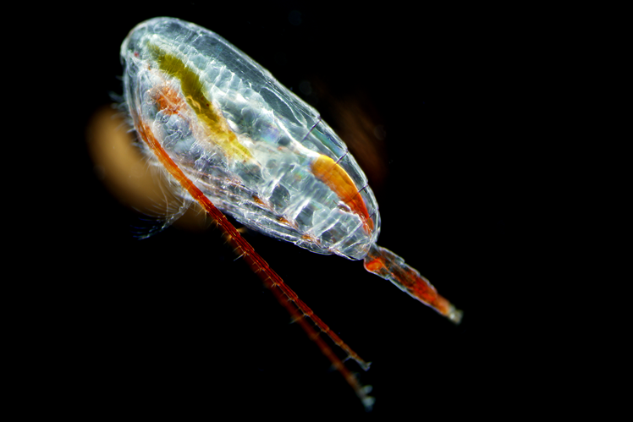
[IMAGE: phytoplankton.png ALIGN: left]

Phytoplankton diversity, stoichiometry and the ocean’s biogeochemistry. Nearly 75 years ago, Alfred C. Redfield observed a similarity between the elemental composition of marine plankton in the surface ocean and dissolved nutrients in the ocean interior This stoichiometry, referred to as the Redfield ratio, continues to be a central tenet in ocean biogeochemistry, and is used to infer a variety of ecosystem processes, such as phytoplankton productivity and rates of nitrogen fixation and loss. Model, field and laboratory studies have shown that different mechanisms can explain both constant and variable ratios of carbon to nitrogen and phosphorus among ocean plankton communities. The range of C/N/P ratios in the ocean, and their predictability, are the subject of much active research. PEBL is collecting samples from around the globe to assess the C/N/P ratios in discrete phytoplankton groups to determine if these ratios are controlled by phylogeny or environmental drivers.

